Arduino Lesson 9
Analog readings
- Intro
We start to learn how to use the analog I/O interface.There
are 6 analog interface(#0-#5).These interfaces can be used
as digital interfaces(#14-#19). Potentiometer is a widely use
analog output electronic part.So we use it to accomplish this
experiment.
- Parts required
Potentiometer x 1
Breadboard x 1
Jumper wires x 1 bundle
- Connect-it-up
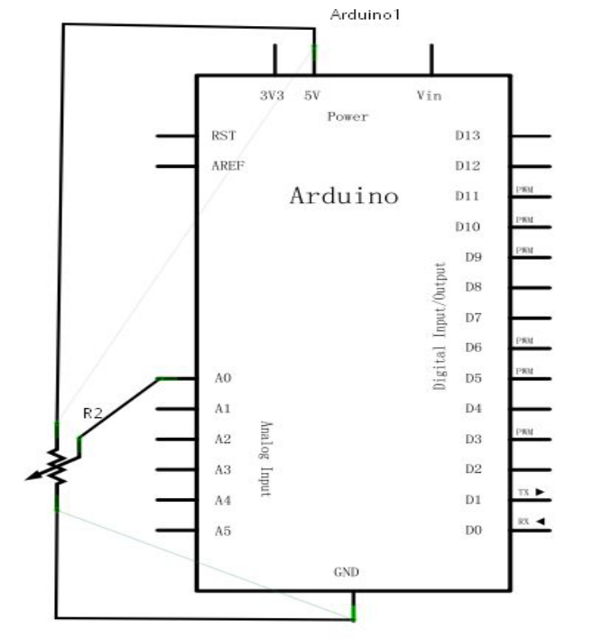
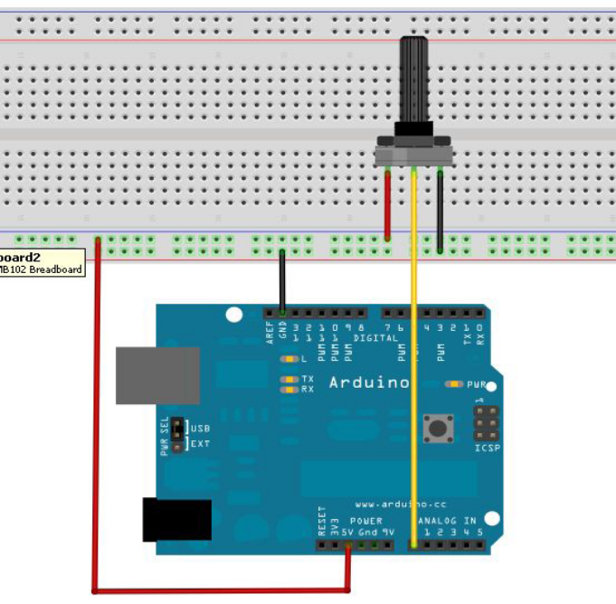
Here we use analog interface #0.
- Experiment Intro.
We will turn the resistance of the potentiometer into analog and read it,display on the screen at last.This experiment contents the functions you need to use in the future experiments.

The program is simple. One function,anlogRead() sentence can
Read the analog value. Arduino 328 is a 10-bit A/D gather,so
The reading range from 0-1023. The difficulty of this experiment is putting the values on screen.

First we need to setup baud rate in voidsetup(),the values means
Commnunications between Arduino and PC,so the baud rate need
To be same, otherwise there would be just messy code or nothing
Displayed.There is a baud rate setup button on right bottom corner of the besel
Window of Arduino.The baud rate here should be same as functon void setup() in program.

The sentence to set up baud rate is Serial.begin();baud rate in the brackets,then it is the sentence display the values, Serial.print(); or Serial.println(); both are ok，difference is the latter automactically return.
- Program for reference
int potpin=0;//Define analog interface #0
int ledpin=13;//Define digital interface #13
int val=0;//Define variable val and assign it to 0
void setup()
{
pinMode(ledpin,OUTPUT);//Definte digital interface as output
Serial.begin(9600);//set the baud rate as 9600
}
void loop()
{
digitalWrite(ledpin,HIGH);//light up led on digital interface #13
delay(50);//delay 0.05 s
digitalWrite(ledpin,LOW);//Turn off #13 LED
delay(50);//delay 0.05 s
val=analogRead(potpin);//read value from analog interface #0 and assign it to val
Serial.println(val);//display value of val
}
This program use #13(LED light) digital interface of Arduino,the led will flash every time it got the reading.
Below is the readings.

Done! You can see the data on the screen is changing while
you twist the potentiometer.

